**Points of Dispensing (POD) Locator**

Points of Contact:

Eva Islam ([eislam@health.nyc.gov](mailto:eislam@health.nyc.gov))

Mustafa Ali ([mali2@health.nyc.gov](mailto:mali2@health.nyc.gov))

DOITT Ticket Number: KSR000001698132

Expected Completion Date: June, 2019

**Table of Contents**

I. Overview………………………………………………………………………………………………...1

II. Expected Data Flow…………………………………………………………………………………...2

III. Requirements………………………………………………………………………………………….3

IV. Appendix……………………………………………………………………………………………….9

**I. Overview**

The Bureau of Emergency Field Operations (BEFO) at the New York City Department of Health and Mental Hygiene (DOHMH) is requesting the creation of a Points of Dispensing (PODs) Locator. The goal of the Locator is to allow members of the public to identify and find their nearest POD Site before and during an emergency. The Locator should allow individuals to search for their address, and determine directions to a nearby POD Site via public transit, driving or walking. It should also display relevant details such as a POD site’s address as a pop-up on the map, and in list form. Given that this will be a public-facing application, the Locator must be Section 508 Compliant to ensure that it is accessible to individuals with disabilities.

This project is related to the POD Management Tool, an ESRI based product that leverages Survey123 and ArcGIS to enable DOHMH staff members to report operational information from active POD sites. The Locator should mirror the interface and functionality of the NYC Hurricane Evacuation Zone finder[1].

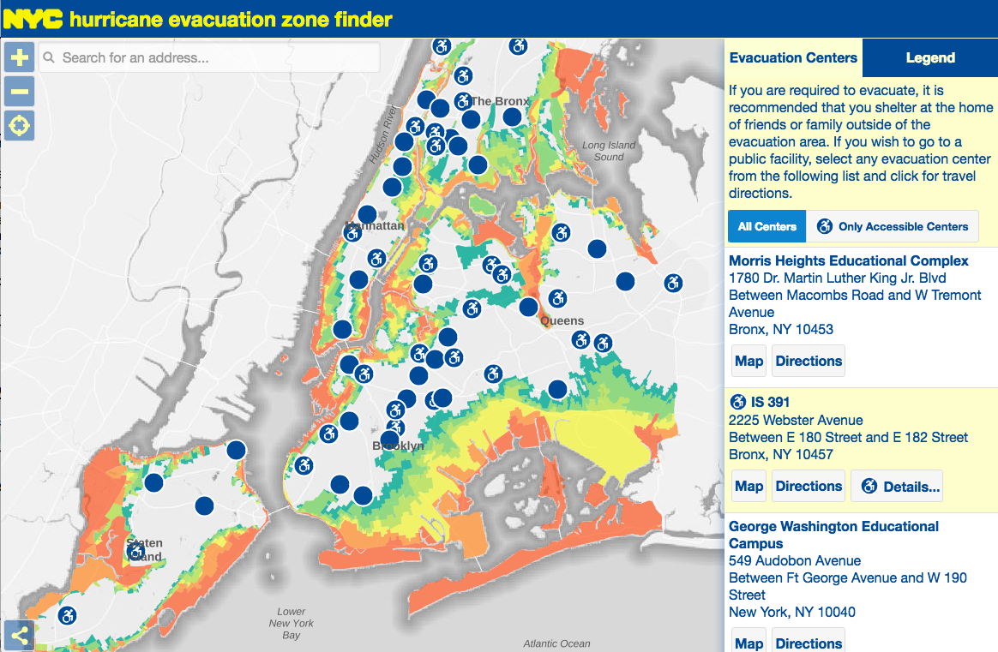

**II. Expected Data Flow**

The Locator should read directly from DOHMH’s ArcGIS Online Locator layer[2]. During a POD activation, staff members at active POD Sites will report out on various indicators including the site’s operations status and its wait time. Individuals will be able to input data directly into their smart phones via Survey123, a form-centric data collection application for ArcGIS Online. Once they have submitted information into the mobile application, the data will populate feature layers in ArcGIS Online. A python script then pushes and pulls these data between ArcGIS Online and a SQL Server database at DOHMH. The Locator layer (*vwLatestDateLocator*) is one of several SQL views that pushes into a feature layer in ArcGIS Online.

ArcGIS Online

DOHMH SQL Server Database

Survey123

(Smart Phone)

DOITT Locator Tool

(maps.nyc.gov)

The POD Locator layer is currently public and accessible to anyone on ArcGIS Online. The layer contains the following fields (the bolded fields are collected via Survey123):

* *DOECode* (type: esriFieldTypeString, length: 4) – POD site’s 4-character DOE code
* *PODSiteName* (type: esriFieldTypeString, length: 150) – POD site’s formal name (starting with the DOE Code)
* *Address* (type: esriFieldTypeString, length: 50) – POD Site’s Street Address
* *Borough* (type: esriFieldTypeString, length: 15) – POD Site’s Borough
* *ZIP* (type: esriFieldTypeString, length: 5) – POD Site’s Zip Code
* *Latitude* (type: esriFieldTypeDouble) – POD Site’s Latitude
* *Longitude* (type: esriFieldTypeDouble) – POD Site’s Longitude
* ***Ops_status*** (type: esriFieldTypeString, length: 16) – POD Site’s Operational Status
* ***wait_time*** (type: esriFieldTypeInteger) – POD Site’s Wait Time
* ***LatestDate* (type: esriFieldTypeDate, length: 8)** – Date and time that the information was last updated via Survey123
* *OpeningTime (type: esriFieldTypeDate, length: 8)* – Expected date and time of POD Site’s Opening*

*\*We will not be displaying this field, but are keeping it as a place holder for potential future uses.*

**III. Requirements**

Overview of Requirements:

|  |  |
| --- | --- |
| **#** | **Description** |
| 1 | Locator can rapidly switch between two states following a POD related emergency:  (a) Pre-Activation State  (b) Activation State |
| 2 | Locator can hide data, and change symbology depending on its state |
| 3 | General Notes for Locator Aesthetics and Text |
| 4 | Locator must be Section 508 compliant and pass review by the NYC DOHMH Communications Office |

*Requirements #1 – Locator can rapidly switch between two states following a POD related emergency: (a) Pre-Activation State (b) Activation State*

Similar to the NYC Hurricane Evacuation Zone finder, the POD Locator must be able to switch between a non-emergency and an emergency state. Both states should display all 165 POD sites at all times.

1. Pre-Activation State:

In this state, the goal of the Locator is to familiarize members of the public with their closest POD site in the event of an emergency. The Locator should display the *PODSiteName* and *Address*, and allow individuals to search for directions from their home/work to a nearby POD site.

1. Activation State:

When PODs are activated, the Locator should display all POD sites’ statuses as being either “Open to Public” or “Closed to Public”. In addition to *Ops_status*, the Locator should also display the Wait Time, and the Latest Update time. The routing functionality should remain the same as in the Pre-Activation State.

*Requirements #2 – Locator can hide data, and change symbology depending on its state*

1. Pre-Activation State:

**Symbology**:

The sites should have the following symbology when PODs are not active:

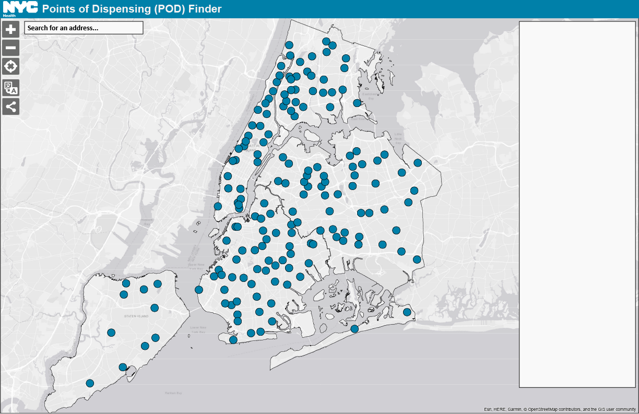

Pre-Activation State:

*Outline color*: #1A1A1A

*Fill color*: #0080A9

*Symbol size*: Same size as symbols in NYCEM Hurricane Evacuation Zone Finder

**Pop-Ups and Panel:**

When PODs are not activated, the pop-up for each POD site should only list its address. Similarly, the panel on the right side of the map should only display the site’s address and no other details.

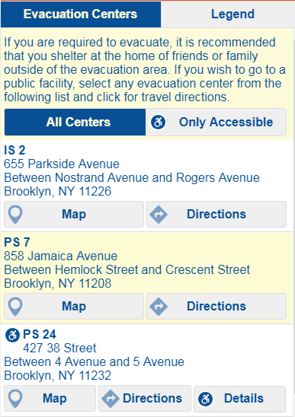

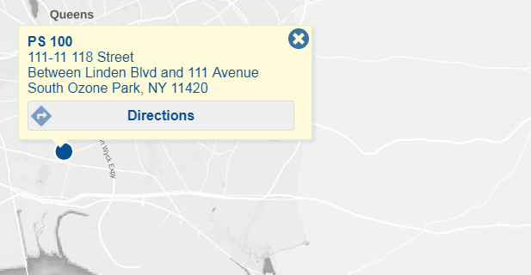

Pre-Activation State:

**[POD Site Name]**

[Address]

[Borough], NY [ZIP]

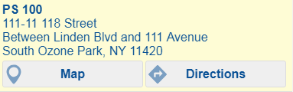

1. Activation State:

**Symbology**:

Following an activation, the Locator should display all POD sites as being either “Open to Public” or “Closed to Public”. They should be grouped by their *Ops_Status* values as denoted below:

|  |  |
| --- | --- |
| **“Open to Public”** | **“Closed to Public”** |
| * Open to Public | * Mobilizing * Demobilizing * Demobilized * Closed to Public * Inactive * *NULL values* |

The points should be color coded as follows:

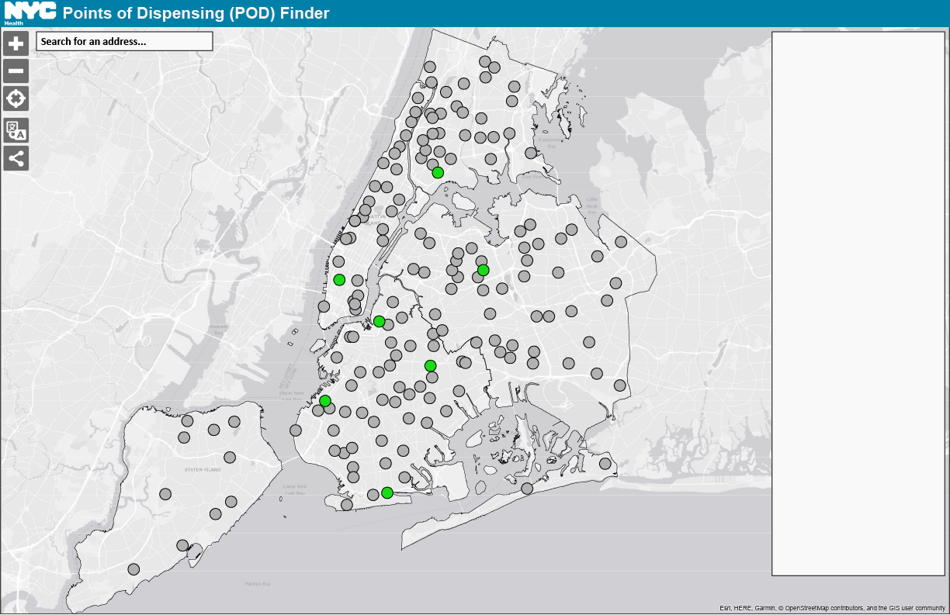

Activation:

**Open to Public**

*Outline color*: #1A1A1A

*Fill color*: #19DB17

*Symbol size*: Same size as symbols in NYCEM Hurricane Evacuation Zone Finder

**Closed to Public**

*Outline color*: #1A1A1A

*Fill color*: #999999

*Symbol size*: Same size as symbols in NYCEM Hurricane Evacuation Zone Finder

Once a POD’s *Ops_status* has changed to “Open to Public” in the REST URL, the point should automatically change colors on the map as specified by the symbology above.

**Pop-ups and Panel**:

Once PODs have activated following an emergency, the pop-ups and panel should include the following fields in the Details section. The *wait_time* and *LatestDate* fields should only appear in the Details section if the POD is “Open to Public”.*

* *Ops_status* (type: esriFieldTypeString, length: 16)
* *wait_time* (type: esriFieldTypeInteger)*
* *LatestDate* (type: esriFieldTypeDate, length: 8)*

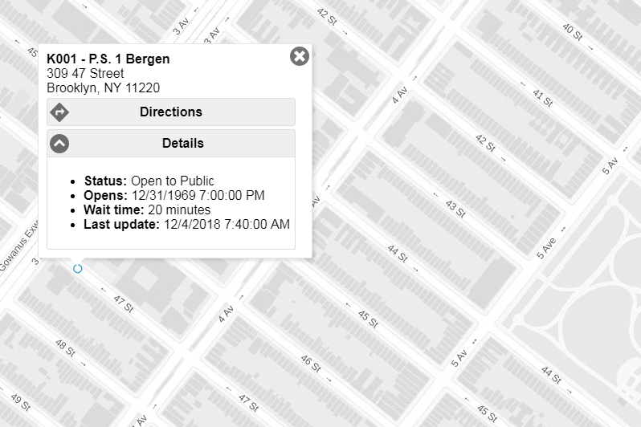

Activation:

**[POD Site Name]**

[Address]

[Borough], NY [ZIP]

Activation:

**[POD Site Name]**

[Address]

[Borough], NY [ZIP]

Activation:

Label: [corresponding field in REST URL]

* **Status**: [Ops_status]
* **Wait Time**: [wait_time] minutes
* **Last Update**: [LatestDate]

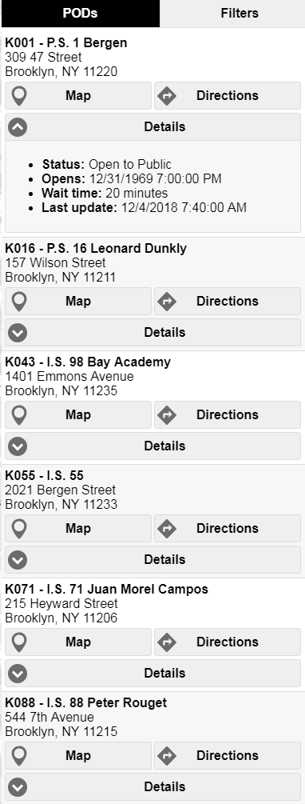

Activation:

Label: [corresponding field in REST URL]

* **Status**: [Ops_status]
* **Wait Time**: [wait_time] minutes
* **Last Update**: [LatestDate]

*Requirements #3 - General Notes for Locator Aesthetics and Text*

The following items should appear on the Locator at all times:

1. The banner at the top of the Locator should say “NYC Points of Dispensing (POD) Finder” at all times. This text should be bolded (*highlighted in magenta*). The color of the banner should match the teal color from the “Emergency Medication Distribution: Points of Dispensing (PODS)” page on the DOHMH website: #0080A9.[3]
2. The text above the panel should say, “All NYC Points of Dispensing Sites are ADA Accessible” at all times (*highlighted in green*).
3. There should be a Home button or something similar that zooms the user back out to show the full extent of the map with all 165 POD sites (*highlighted in light blue*).

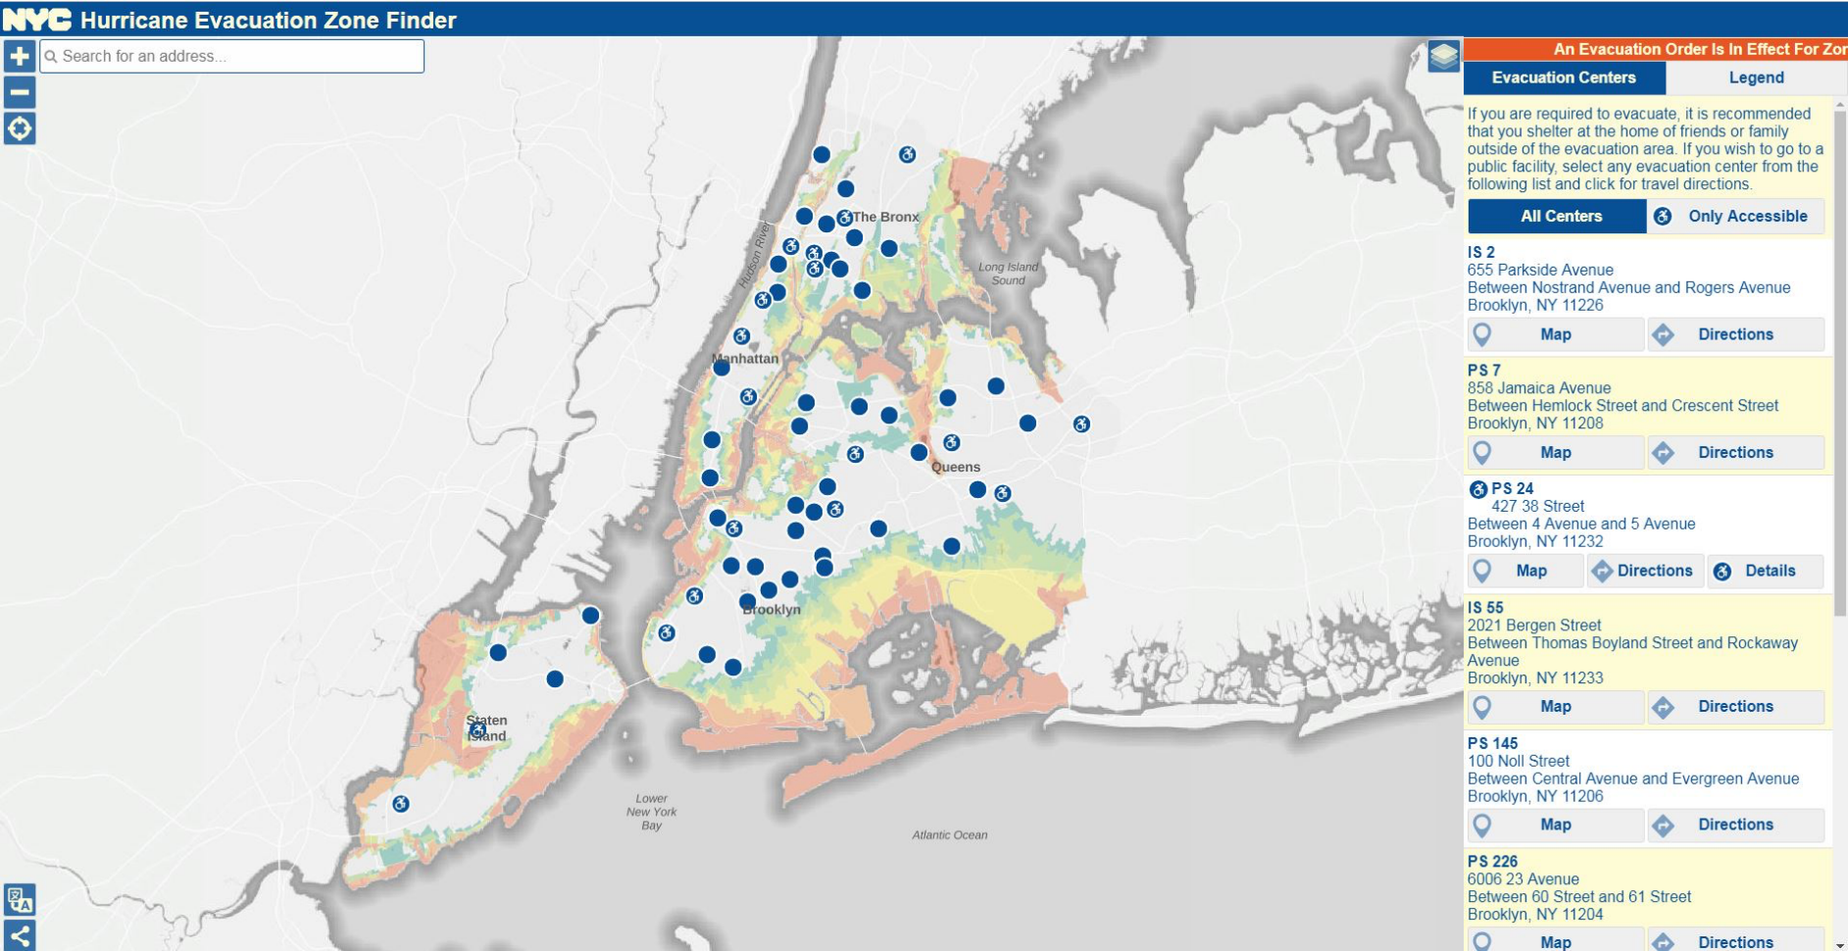

All NYC Points of Dispensing Sites are ADA Accessible.



*From NYC Hurricane Zone Finder4*

*Requirements #4 – Locator must be Section 508 compliant and pass review by the NYC DOHMH Communications Office*

The Locator should incorporate the following items to ensure that it is Section 508 compliant:

1. Colorblind safe symbology
2. High color contrast
3. Accessible fonts
4. Screen reader accessibility
5. Text labels for all links, buttons and form controls
6. Keyboard navigation

**IV. Appendix**

1. NYCEM Hurricane Evacuation Zone Finder:

<https://maps.nyc.gov/hurricane/>

1. NYCEM Hurricane Evacuation Zone Finder (new):

<https://csgis-stg-prx.csc.nycnet/hurricane/>

1. DOHMH Locator Layer (*vwLatestDateLocator*) REST URL: <https://services3.arcgis.com/A6Zjpzrub8ESZ3c7/arcgis/rest/services/vwLatestDateLocator/FeatureServer/0?token=Zzb_3VHi6P-vmmU1XIqNhecOxfeFn996aiuzhm3-BLLMP8clL76ed3TyE2se9mS4TpN3IIhvNFp4e1LmbE9w-TKAVL4g7MhK2eLPxgMMC-yC1AXPKPlfp-qcixGgLPq-PFkKulPV_dNowB_AVGZw_a-1XD3cvDpmUdffRA_wcihf_IUc1kNBEiPfn7QxGrPEDKE0rvPUFx-AkjRP2IjTM1dKjUO8v_gJOpR5osgV3KGsR_oVQydPF-aUWy419ZnV>
2. DOHMH Points of Dispensing Web Page:

<https://www1.nyc.gov/site/doh/health/emergency-preparedness/emergency-medication-distribution.page>

1. DOHMH Locator Prototype (ArcGIS Online Webapp): <https://nycdohmh.maps.arcgis.com/apps/webappviewer/index.html?id=e4955603fe704405b5f79414e9916600>
2. DOITT POD Finder (Prototype):

<https://csgis-dev-web.csc.nycnet/gis/data/apps/mobile/pods/>

1. NYCEM Hurricane Evacuation Zone Finder (Appendix (1))
2. DOHMH Locator Layer (*vwLatestDateLocator*) REST URL (Appendix (2))
3. 3 DOHMH Points of Dispensing Web Page (Appendix (3))

   4 NYCEM Hurricane Evacuation Zone Finder (new) (Appendix (2))